I will attempt to tell a story of food insecurity in the US through data visualizations. The aim is to see the differences in rates between the states, as well as explore various food insecure household types throughout the years. This will be done using reputable data and various programming tools, languages, and libraries.

Dataset: [USDA](https://www.ers.usda.gov/topics/food-nutrition-assistance/food-security-in-the-us/interactive-charts-and-highlights/)

Dataset: [Feeding](https://drive.google.com/drive/folders/1UfVDDV5s6EmfDVd6umg9ecXJoGy_pD_0?usp=sharing) [America](https://www.feedingamerica.org/research/map-the-meal-gap/by-county?s_src=WXXX1MTMG&_ga=2.36662816.1400661717.1595009512-1249045837.1595009512)

GitHub Repo: <https://github.com/m-vasquez/Project2-Food-Insecurity-in-the-US>

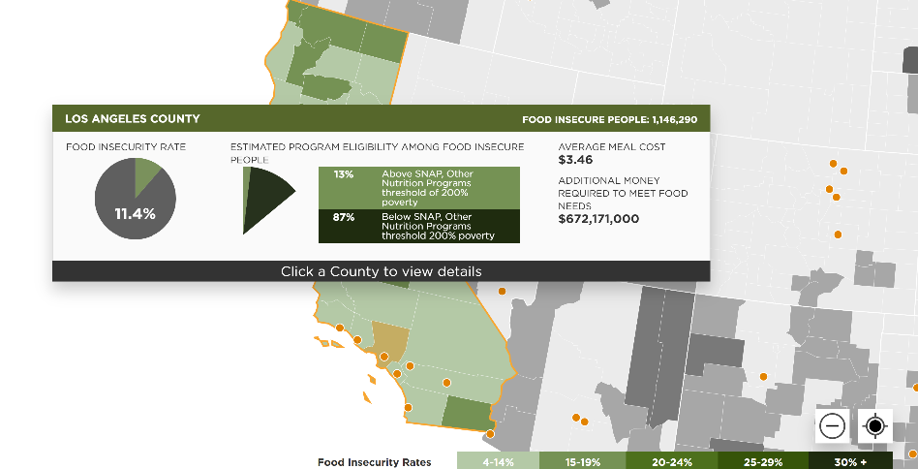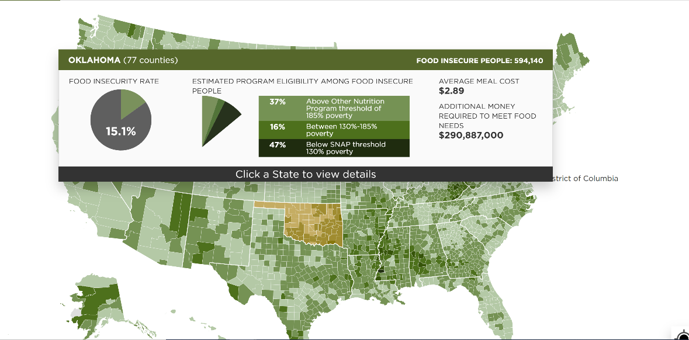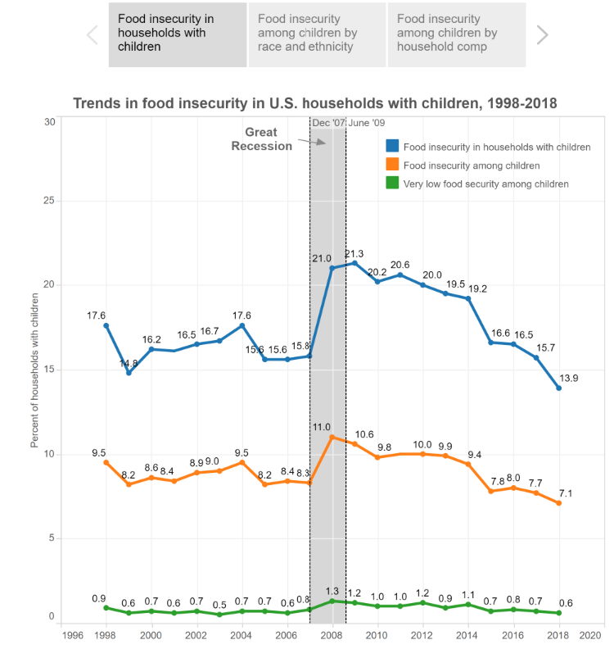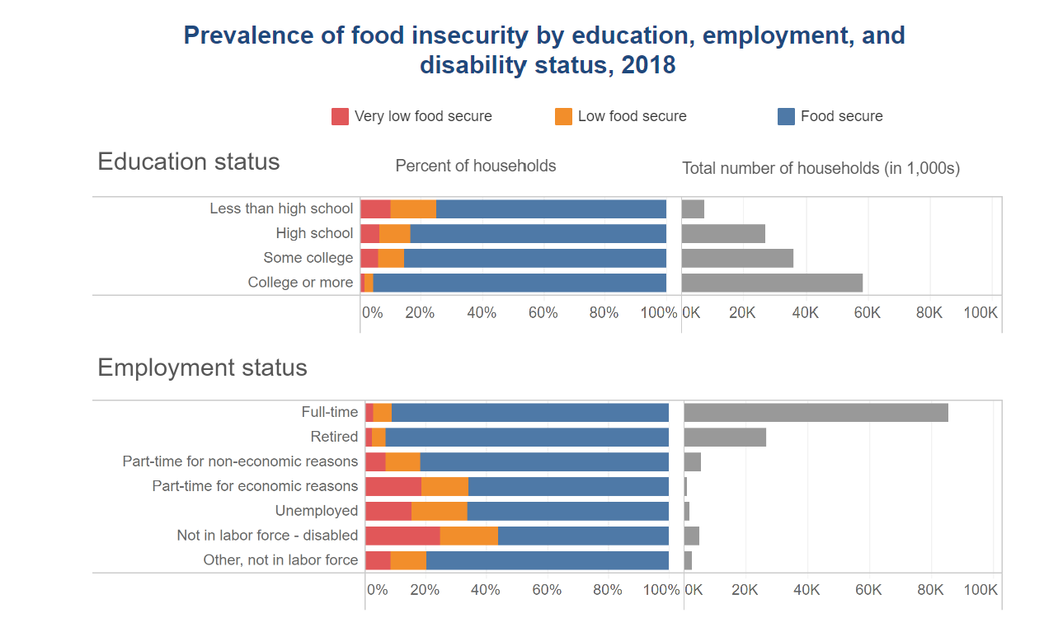

**Food Insecurity Trends Through the Years**

Use the interactive charts below to learn about food insecurity in the US

Food Insecurity in the US Broken Down

Select a Year Block

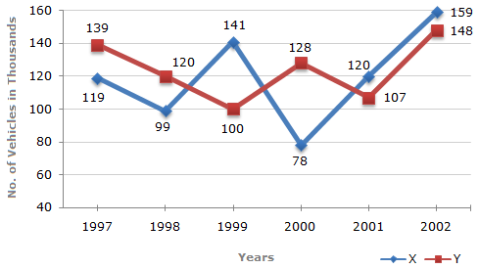

**Food Insecurity Map- 2018**

Use the interactive charts below to learn about food insecurity in the US

Select multiple Household (HH) Categories

[2018]

[HH w/Elderly]

Select a County

[County]

National

Select a State